Universidad Nacional

José Faustino Sánchez Carrión

FACULTAD DE CIENCIAS SOCIALES

SÍLABO POR COMPETENCIAS
INGLÉS II
2017-I

SÍLABO: INGLÉS II
2017 - I

- DATOS GENERALES

LÍNEA DE CARRERA | FORMACION GENERAL
CURSO | INGLÉS II
CÓDIGO
HORAS | 5 horas semanales

II. SUMILLA Y DESCRIPCIÓN DEL CURSO

El curso de Inglés II es de naturaleza teórico-práctico, perteneciente al área de Formación General. Es el segundo de un sistema de asignaturas que tiene como objetivo el desarrollo de la competencia comunicativa profesional en lengua extranjera. Su propósito es afianzar y ampliar el desarrollo de las habilidades comunicativas correspondientes al nivel básico alcanzado en el Inglés I.

Está basado en un enfoque comunicativo que ayuda al estudiante a adquirir y practicar el idioma a través del desarrollo de las cuatro habilidades básicas, además le permite al estudiante obtener mayores conocimientos en gramática y en vocabulario, lo que dará al estudiante mayor confianza y fluidez al momento de comunicarse en diversas situaciones.

El curso está programado en 17 semanas, en las cuales se desarrollan IV Unidades didácticas con sus respectivas sesiones de aprendizaje y tiene una duración de 5 horas semanales.

- CAPACIDADES AL FINALIZAR EL CURSO

 | CAPACITY UNIT | NAME UNIT | WEEKS
UNIT I | Talk about the importance of a family in our context.  Identify main ideas and supporting details of a text.  Produce simple coherent texts about familiar subjects.  Describe specific objects and ongoing events. | “My family and clothes and shopping” | 1, 2, 3, 4
UNIT II | Asking and answering questions in present and past events  Talking about vacations activities.  Recognize the functions of written texts according to form and purpose.  Use known vocabulary and grammatical structures to write texts.  Identify the communicative purpose of the text.  . | Writing past events | 5, 6, 7, 8
UNIT III | Asking and answering questions about different activities in past.  Talk about about past habits and situations..  Recognize the functions of written texts according to form and purpose.  Distinguishing between past and present activities  Talking about ability in the past.  Telling a story.. | What happened? | 9, 10, 11, 12
UNIT IV | Asking and answering questions about different activities.  Talk about past prgressive.  Recognize the functions of written texts according to form and purpose.  Use known vocabulary and grammatical structures to write texts.  Identify the communicative purpose of the text.  Infer information from written texts.  Produce different texts with appropriateness, coherence and cohesion. | Action happening in the past. | 13, 14, 15, 16 17

- INDICADORES DE CAPACIDADES AL FINALIZAR EL CURSO
1 | Talk about have a family in our context.
2 | Identify mains ideas of a text.
3 | Produce simple coherent text about familiar subjects.
4 | Describe specific objects and ongoing events.
5 | Produce simple coherent texts to describe specific objects and ongoing events.
6 | Produce texts that achieve appropriateness, clarity, emphasis and coherence.
7 | Talking in class, answer the questions correctly.
8 | Asking and answering about activities and events in the past..
9 | Asking and answering questions about present and past events.
10 | Talking about past habits and situations.
11 | Distinguishing between past and present activities.
12 | Talking about ability in the past.
13 | Write short texts in past / Discuss the questions.
14 | Telling a story using connectors.
15 | Complete the sentences in negative form.
16 | Conversation answers the questions.
17 | Talk about your project.

- DESARROLLO DE LAS UNIDADES DIDACTICAS:
Unit I: “My family and clothes and shopping” |  | CAPACITY OF UNIT I: Identify main ideas and supporting details of a text. Produce simple coherent texts about familiar subjects and describe specific objects and ongoing events.
UNIT I :“My family and clothes and shopping” | Weeks |  |  | Contents |  |  |  |  |  |  |  |  |  |  | Teaching strategy |  | Achievement indicators of capacity
 |  |  |  | Conceptual |  |  | Procedural |  |  |  |  | Attitudinal
 | 1 |  |  | - Possessive adjectives  - Demonstrative adjectives |  |  | - Talking about families.  - Talking about clothing items |  |  |  |  | Appreciate family relationships |  |  | Look at a family tree and identifies family members. |  | Describe one’s family using possessive and demonstrative adjectives.
 | 2 |  |  | - Verb “to have”: simple present  - Apostrophe |  |  | - Indicating possession  - Filing a form |  |  |  |  | Appreciate civic values |  |  | Complete and write sentences with the verb have. |  | Identify main ideas and supporting details of a text about the family.
 | 3 |  |  | - Opposite adjectives |  |  | - Talking about clothes and shopping. |  |  |  |  | Value the topics presented in the unit |  |  | Write opposite adjectives in a short text. |  | Describe opposite adjectives in a text.
 | 4 |  |  | - Order of adjectives |  |  | - Gving detailed description of something |  |  |  |  | Appreciate his/her learning process |  |  | Look at clothing of people and describe them using adjectives. |  | Produce written texts to give detailed description of something considering order of adjectives.
 |  |  |  | UNIT EVALUATION |  |  |  |  |  |  |  |  |  |  |  |  |  |  |  |  |  |  |  |  |  |  | Escucha y comprende información brindada por su interlocutor acerca de su nombre, correo y número de teléfono.
 |  |  |  | EVIDENCE OF KNOWLEDGE |  |  |  |  | EVIDENCE OF PRODUCT |  |  |  |  |  |  |  | EVIDENCE OF PERFORMANCE |  |  |  |  |  | Dialoga acerca de donde son las personas utilizando vocabulario de países y nacionalidades.
 |  |  |  | Oral and written evaluation of the Unit I |  |  |  |  | Make a photo album describing what happening in each picture. |  |  |  |  |  |  |  | Formulates a procedure for the best learning of possessive adjectives with verb to have. |  |  |  |  |  | Elabora un poster sobre su personaje favorito utilizando la tercera persona del singular del verbo TO BE y lo expone en clase.
Unit II : Writing past events. |  | CAPACITY OF UNIT II: Produce simple coherent texts to describe specific objects and ongoing events, produce texts that achieve appropriateness, clarity, emphasis and coherence,
 |  | Week | Contents |  |  |  |  |  |  |  |  |  |  | Teaching strategy |  | Achievement indicators of capacity
 |  |  | Conceptual |  |  | Procedural |  |  |  |  | Attitudinal
 |  | 5 | - Past tobe in affirmative form with time expression.  - Past tobe in negative form. |  |  | - Writing about vacations  - Talking about the weather. |  |  |  |  | Understand past events as part of life experience. |  |  | .work in group and write text about the topics. |  | Produce texts that achieve appropriateness, clarity, emphasis and coherence.
 |  | 6 | - Past tobe in interrogative form with short answer. |  |  | - Talking about past events  - Exchanging information about the past. |  |  |  |  | Respect their ideas our opinions of their partners. |  |  | Work in pairs.  Colaborative learning. |  | Talking in class.  Answer the questions correctly.
 |  | 7 | - There was and there were. |  |  | - To narrate a story and write about past event happened. |  |  |  |  | Show responsability |  |  | Do exercises and demonstrate what learned. |  | Produce simple coherent texts to describe past events.
 |  | 8 | - Project abaut the topic. |  |  | - Present and expositions your work |  |  |  |  | Be organize and cooperative. |  |  | Expositions in class. |  | Talk about your project.
 |  |  | EVALUACIÓN DE LA UNIDAD DIDÁCTICA |  |  |  |  |  |  |  |  |  |  |  |  |  |  |  |  |  |  |  |  |  |  | Escucha y comprende información brindada por su interlocutor acerca de su nombre, correo y número de teléfono.
 |  |  | EVIDENCIA DE CONOCIMIENTOS |  |  |  |  | EVIDENCIA DE PRODUCTO |  |  |  |  |  |  |  | EVIDENCIA DE DESEMPEÑO |  |  |  |  |  | Dialoga acerca de donde son las personas utilizando vocabulario de países y nacionalidades.
 |  |  | Oral and written evaluation of the Unit II. |  |  |  |  | Write short text with the past tobe in past with pictures in class. |  |  |  |  |  |  |  | Prepare exposition for different topics for better learning. |  |  |  |  |  | Elabora un poster sobre su personaje favorito utilizando la tercera persona del singular del verbo TO BE y lo expone en clase.
Unit III : How it all started /What happened. |  | CAPACITY OF UNIT III: Asking and answering activities in past./ Talking about the past habits and situation./Telling a story n past.
 |  | Weeks | Contents |  |  |  |  |  |  |  |  |  | Teaching strategy |  |  | Achievement indicators of capacity
 |  |  | Conceptual |  | Procedural |  |  |  |  | Attitudinal
 |  | 9 | - Simple Past & the verb tobe  - Regular verb |  | - Read the text and answer the questions.  - Complete the sentences |  |  |  |  | Work in class.  Show solidarity with your partners. |  |  | Work in group during the practice.  Talking in pairs short conversations. |  |  | Asking and answering activities and events in the past.  Asking and answering questions about present and past.
 |  | 10 | - Simple past of irregular verbs (affirmative form)  - Adverbs of manner. |  | - Listen the vocabulary about animals.  - Read short text and talking about the principal ideas. |  |  |  |  | Work actively during the class.  Respect the opinions of your partners. |  |  | Work in pair during the reading and answer the questions.  Write true or false the sentences. |  |  | Talking about the past habits and situations.  Distinguishing between past and present activities
 |  | 11 | - Past Simple Negative and interrogative form. |  | - Practice a short conversation What do you think happened ..... |  |  |  |  | Show Positive attitude.  Help your partnets. |  |  | Listen again and check your answers.  Talk in pairs. Answer the questions. |  |  | Talking about ability in the past.  Telling a story.
 |  | 12 | - Project abaut the topic. |  | - Present and expositions your work |  |  |  |  | Be organize and cooperative. |  |  | Expositions in class. |  |  | Talk about your project.
 |  |  | EVALUACIÓN DE LA UNIDAD DIDÁCTICA |  |  |  |  |  |  |  |  |  |  |  |  |  |  |  |  |  |  |  |  |  |  | Escucha y comprende información brindada por su interlocutor acerca de su nombre, correo y número de teléfono.
 |  |  | EVIDENCIA DE CONOCIMIENTOS |  |  |  |  | EVIDENCIA DE PRODUCTO |  |  |  |  |  |  |  | EVIDENCIA DE DESEMPEÑO |  |  |  |  |  | Dialoga acerca de donde son las personas utilizando vocabulario de países y nacionalidades.
 |  |  | Oral and written evaluation of the Unit III. |  |  |  |  | Telling and write short story in past. |  |  |  |  |  |  |  | Talking about actions in past. |  |  |  |  |  | Elabora un poster sobre su personaje favorito utilizando la tercera persona del singular del verbo TO BE y lo expone en clase.

Unit IV : Actions happening in the past | CAPACITY OF UNIT IV: Write short texts in past progressive, sequencing the parts of a story using connectors,
 | Week | Contents |  |  |  | Teaching strategy | Achievement indicators of capacity
 |  | Conceptual | Procedural |  | Attitudinal
 | 13 | - Past progressive with tourist place in affirmative form. | - Write about past events |  | Show self-steem and confidence. | Writing about past events. | Write short texts in past progressive.
 | 14 | - Connectors of time: before / while / now / that | - Expressing relationship between ideas. |  | Consider the importance of moral values.. | Underline the connector in a text. | Sequencing the parts of a story.  Telling a story using connectors.
 | 15 | - Past progressive in negative form. | - Writing about strange events and negative sentences. |  | Considere the importance of moral values. | Write sentences in negative form. | Complete the sentences in negative form.
 | 16 | - Past progressive in interrogative form with short answer. | - In pairs students practice answer the questions. |  | Show empathy for others. | Work in pair show respect between partners. | Conversation answers the questions.
 | 17 | - Project abaut the topic. | - Present and expositions your work |  | Be organize and cooperative. | Expositions in class. | Talk about your project.
 |  | EVALUACIÓN DE LA UNIDAD DIDÁCTICA |  |  |  |  |  |  |  |  |  | Escucha y comprende información brindada por su interlocutor acerca de su nombre, correo y número de teléfono.
 |  | EVIDENCIA DE CONOCIMIENTOS |  | EVIDENCIA DE PRODUCTO |  |  | EVIDENCIA DE DESEMPEÑO |  |  | Dialoga acerca de donde son las personas utilizando vocabulario de países y nacionalidades.
 |  | Oral and written evaluation of the Unit III. |  | .short text. |  |  | Write short text with the past progressive. |  |  | Elabora un poster sobre su personaje favorito utilizando la tercera persona del singular del verbo TO BE y lo expone en clase.

VI.MATERIALES EDUCATIVOS Y OTROS RECURSOS DIDÁCTICOS
Se utilizarán todos los materiales y recursos requeridos de acuerdo a la naturaleza de los temas programados. Básicamente serán:

  - MEDIOS ESCRITOS.
- Separatas con contenidos temáticos
- Lecturas
- Prácticas
- Diccionario

  - MEDIOS VISUALES Y ELECTRONICOS.
- Papelotes
- Tarjetas
- Diapositivas
- Proyector multimedia

  - MEDIOS INFORMATICOS.
- Internet

VII. EVALUACIÓN

  - EVIDENCIAS DE CONOCIMIENTO.
Se proyectan en dos direcciones: analítico y autoevaluación. En cuanto al primer caso, medir la competencia a nivel interpretativo, argumentativo y propositivo, para ello debemos ver cómo identifica (describe, ejemplifica, relaciona, reconoce, explica, etc.); y la forma en que argumenta (plantea una afirmación, describe las refutaciones en contra de dicha afirmación, expone sus argumentos contra las refutaciones y arriba a conclusiones para corroborar la afirmación inicial) y la forma en que propone a través de establecer estrategias, valoraciones, generalizaciones, formulación de hipótesis, respuesta a situaciones, etc.

En cuanto a la autoevaluación permite que el estudiante evidencie sus fracasos y sus éxitos, su autorregulación.

Las evaluaciones de este nivel serán de respuestas simples, opción dicotómica, opción múltiple, de correlación, preguntas calculadas, percepción y valoración de videos, entre otros.

  - EVIDENCIA DE DESEMPEÑO.
Son pruebas en torno al manejo que el alumno hace de procedimientos y técnicas para realizar un actividad o resolver un problema. Esta evidencia pone en acción recursos cognitivos, recursos procedimentales y recursos afectivos; todo ello en una integración que evidencia un saber hacer reflexivo; en tanto, se puede verbalizar lo que se hace, fundamentar teóricamente la práctica y evidenciar un pensamiento estratégico, dado en la observación en torno a cómo se actúa en situaciones impredecibles.

La evaluación de desempeño se evalúa ponderando cómo el estudiante aplica los procedimientos y técnicas en el diseño del trabajo y su desarrollo sistemático.

  - EVIDENCIA DE PRODUCTO.
Están implicadas en las finalidades de la competencia, por tanto no es simplemente la entrega del producto, sino que tiene que ver con el campo de acción y los requerimientos del contexto de aplicación.

La evaluación de producto se evidencia en la entrega oportuna de sus trabajos parciales de cada mes y el producto final.

Además se tendrá en cuenta la asistencia como componente del desempeño, el 30% de inasistencia inhabilita el derecho a la evaluación. El ponderado es el siguiente: Teórico Práctico 1, 35%; Teórico Práctico 2, 35% y el Trabajo Académico, 30%. El promedio final es la suma de los ponderados.

VIII. BIBLIOGRAFÍA Y REFERENCIAS WEB

Bygrave, J. (2012) New Total English. Students’ Book – Starter. England: Pearson.

Mitchell, H. & Scott, J. American Channel (2012) Beginners Student’s Book. EEUU: mm publications.

University of Cambridge (2013) Advanced Learner’s Dictionary. United Kingdom: Cambridge University Press.

Wipipedia (2017) Cinematography. Recuperado de https://en.wikipedia.org/wiki/
Cinematography.

Landecker, H. (2006). "Microcinematography and the History of Science and Film". doi:10.1086/501105

Widescreen Journal (2011.) The film producer as a creative force.

Huacho, 03 de abril, 2017

_______________________________________
Mg. ELENA CRISTINA GUERRERO PUELLES
Docente del Curso

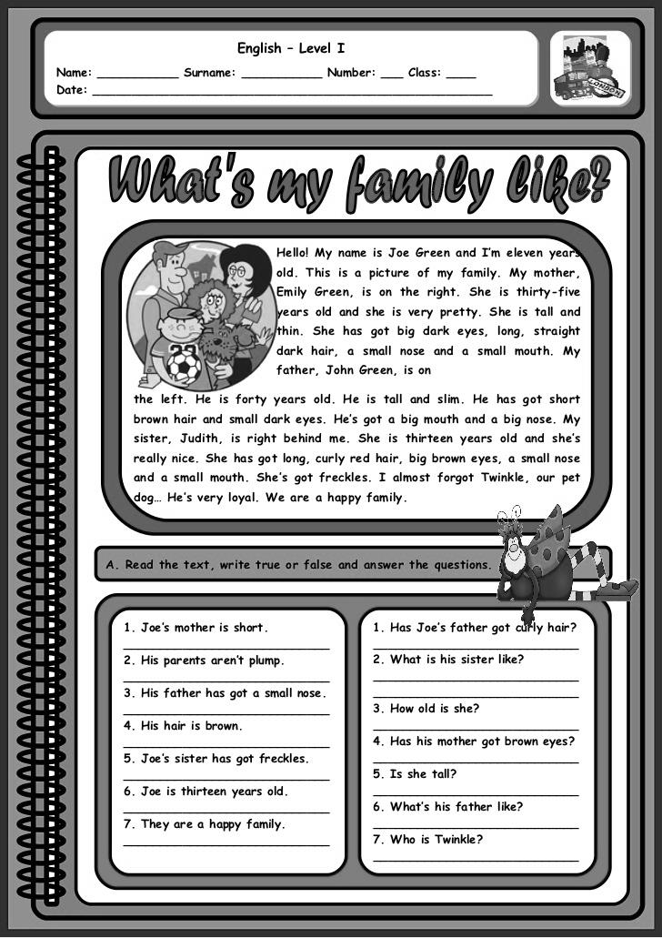
VI.MATERIALES EDUCATIVOS Y OTROS RECURSOS DIDÁCTICOS
Se utilizarán todos los materiales y recursos requeridos de acuerdo a la naturaleza de los temas programados. Básicamente serán:

  - MEDIOS ESCRITOS.
- Separatas con contenidos temáticos
- Lecturas
- Prácticas
- Diccionario

  - MEDIOS VISUALES Y ELECTRONICOS.
- Papelotes
- Tarjetas
- Diapositivas
- Proyector multimedia

  - MEDIOS INFORMATICOS.
- Internet

VII. EVALUACIÓN

  - EVIDENCIAS DE CONOCIMIENTO.
Se proyectan en dos direcciones: analítico y autoevaluación. En cuanto al primer caso, medir la competencia a nivel interpretativo, argumentativo y propositivo, para ello debemos ver cómo identifica (describe, ejemplifica, relaciona, reconoce, explica, etc.); y la forma en que argumenta (plantea una afirmación, describe las refutaciones en contra de dicha afirmación, expone sus argumentos contra las refutaciones y arriba a conclusiones para corroborar la afirmación inicial) y la forma en que propone a través de establecer estrategias, valoraciones, generalizaciones, formulación de hipótesis, respuesta a situaciones, etc.

En cuanto a la autoevaluación permite que el estudiante evidencie sus fracasos y sus éxitos, su autorregulación.

Las evaluaciones de este nivel serán de respuestas simples, opción dicotómica, opción múltiple, de correlación, preguntas calculadas, percepción y valoración de videos, entre otros.

  - EVIDENCIA DE DESEMPEÑO.
Son pruebas en torno al manejo que el alumno hace de procedimientos y técnicas para realizar un actividad o resolver un problema. Esta evidencia pone en acción recursos cognitivos, recursos procedimentales y recursos afectivos; todo ello en una integración que evidencia un saber hacer reflexivo; en tanto, se puede verbalizar lo que se hace, fundamentar teóricamente la práctica y evidenciar un pensamiento estratégico, dado en la observación en torno a cómo se actúa en situaciones impredecibles.

La evaluación de desempeño se evalúa ponderando cómo el estudiante aplica los procedimientos y técnicas en el diseño del trabajo y su desarrollo sistemático.

  - EVIDENCIA DE PRODUCTO.
Están implicadas en las finalidades de la competencia, por tanto no es simplemente la entrega del producto, sino que tiene que ver con el campo de acción y los requerimientos del contexto de aplicación.

La evaluación de producto se evidencia en la entrega oportuna de sus trabajos parciales de cada mes y el producto final.

Además se tendrá en cuenta la asistencia como componente del desempeño, el 30% de inasistencia inhabilita el derecho a la evaluación. El ponderado es el siguiente: Teórico Práctico 1, 35%; Teórico Práctico 2, 35% y el Trabajo Académico, 30%. El promedio final es la suma de los ponderados.

VIII. BIBLIOGRAFÍA Y REFERENCIAS WEB

Bygrave, J. (2012) New Total English. Students’ Book – Starter. England: Pearson.

Mitchell, H. & Scott, J. American Channel (2012) Beginners Student’s Book. EEUU: mm publications.

University of Cambridge (2013) Advanced Learner’s Dictionary. United Kingdom: Cambridge University Press.

Wipipedia (2017) Cinematography. Recuperado de https://en.wikipedia.org/wiki/
Cinematography.

Landecker, H. (2006). "Microcinematography and the History of Science and Film". doi:10.1086/501105

Widescreen Journal (2011.) The film producer as a creative force.

Huacho, 03 de abril, 2017

_______________________________________
Mg. ELENA CRISTINA GUERRERO PUELLES
Docente del Curso

Huacho, Abril, 2017

_______________________________________
Mg. ELENA CRISTINA GUERRERO PUELLES
Docente del Curso

Family Relationships :
Male | Female | Relationship
Father | Mother | Parent
"Dad" | "Mom" | Parent
Son | Daughter | Child
Husband | Wife | Spouse
Brother | Sister | Sibling
Grandfather | Grandmother | Grandparent(s)
"Grandpa" | "Grandma" | Grandparent(s)
Grandson | Granddaughter | Grandchild(ren)
Uncle | Aunt | Parent's sibling
Nephew | Niece | Sibling's child(ren)
Cousin | Cousin | Aunt/Uncle's child(ren)

List of common English first names (male)
Adam | Alan | Andy | Austin | Ben | Brad
Bruce | Caleb | Carl | Chad | Colin | Cory
Craig | David | Dean | Dennis | Don | Edward
Eric | Ethan | Felix | Frank | Gabriel | Gary
Glen | Greg | Hayden | Howard | Ian | Ivan
Jack | Jared | Jason | Joe | John | Justin
Keith | Karl | Kevin | Lane | Lee | Lionel
Luke | Matt | Mike | Nathan | Nick | Oscar
Otto | Patrick | Phillip | Quentin | Raymond | Rex
Robert | Ron | Roy | Ryan | Samuel | Scott
Shawn | Simon | Steven | Terry | Timothy | Troy
Victor | Vincent | Wayne | William | Zack | Zane

List of common English first names (female)
Abby | Adrianna | Alice | Ann | Angie | Barbara
Betty | Britney | Candice | Cassie | Christine | Cindy
Dawn | Debbie | Diana | Dixie | Elaine | Ellen
Emily | Emma | Fawn | Freda | Gina | Gloria
Heather | Heidi | Holly | Ida | Ingrid | Irene
Jane | Janet | Janice | Jean | Jill | Joan
Jody | Joy | Judy | Julie | Karen | Kathy
Kimberly | Laura | Lena | Lisa | Lori | Maggie
Marla | Mary | May | Michelle | Monica | Nancy
Naomi | Nicole | Olga | Pamela | Patty | Paula
Peggy | Phyllis | Rachel | Rebecca | Rhonda | Ruth
Sabrina | Sally | Sarah | Shelly | Sherry | Tammy
Tina | Tonya | Tracy | Veronica | Vicky | Wendy

EXPRESSIONS
Saying hello
Good morning/afternoon/evening.
Hello./Hi.
How are you?
(I'm) great. Thank you./Thanks.
(just) fine.
not bad.
OK.
Saying good-bye
Good-bye./Bye./Bye-bye.
Good night.
See you later/tomorrow.
Have a good evening/a nice day.
Thanks./You, too.
Introducing yourself
Hi. My name is . . .
I'm . . . .
It's nice to meet you, . . . .
Nice to meet you, too.
Exchanging personal information
What's your name?
I'm . . . ./My name is . . . .
What's your phone number?
It's . . . .
Checking and confirming information
What's your last name again?
It's . . . .
How do you spell . . . ?
Is that . . . ?
Yes, that's right./No, it's . . . .
Are you . . . ?
No, I'm not./Yes, I am.
Introducing someone
. . . , this is . . . .
Hi, . . . . It's nice to meet you.
Apologizing
I'm sorry.
Getting someone's attention
Excuse me.
Giving an opinion
I think . . . .

Plan of Intro Book
Title/Topics | Functions | Grammar | Listening/  Pronunciation | Writing/Reading | Interchange Activity
Unit 1 Pages 2–7 |  |  |  |  | Unit 1
It's nice to meet you.  Alphabet; greetings and leave-takings; names and titles of address; numbers 1–10 and telephone numbers | Introducing yourself and friends; saying hello and good-bye; asking for names and phone numbers | Possessive adjectives my,your, his, her;the verb be:affirmative statements and contractions | Listening for the spelling of names; listening for telephone numbers  Pronunciation of the alphabet and numbers 1–10 | Writing a list of telephone numbers | "Directory assistance": Calling the operator to find out phone numbers  Pages IC-2 and IC-4
Unit 2 Pages 8–13 |  |  |  |  | Unit 2
What's this?  Possessions, classroom objects, personal items, and locations in a room | Naming objects; asking for and giving the location of an object | Articles a, an,and the; this/itand these/they;plurals; yes/no and wherequestions withbe; prepositions of place | Listening to find the location of an item  Pronunciation of plural s | Writing the location of objects | "Find the differences": Comparing two rooms  Page IC-3
Unit 3 Pages 14–19 |  |  |  |  | Unit 3
Where are you from?  Cities, countries, and regions; adjectives of personality; numbers to 100 and age | Talking about geographical locations; asking for and giving information about places of origin, nationality, native language, and age; describing people | The verb be:affirmative and negative statements, yes/no questions, short answers, and Wh-questions | Listening for countries and languages; listening to descriptions of people  Syllabic stress of numbers; blending with isand are | Writing questions requesting personal information | "Class personalities": Identifying classmates' personality traits  Page IC-5
Unit 4 Pages 20–25 |  |  |  |  | Unit 4
I'm not wearing boots!  Clothing; colors; seasons of the year; weather | Asking about and describing clothing; talking about the weather; finding the owner of an item | Possessive adjectives our, their, and possessives of names; present continuous affirmative and negative statements; isn'tand aren't;conjunctions andand but; color adjectives before nouns | Listening for descriptions of clothing  Sentence stress and rhythm | Writing questions about what people are wearing | "Celebrity fashions": Describing celebrities' clothing  Pages IC-6 and IC-7
Review of Units 1–4 Pages 26–27
Title/Topics | Functions | Grammar | Listening/  Pronunciation | Writing/Reading | Interchange Activity
Unit 5 Pages 28–33 |  |  |  |  | Unit 5
What are you doing?  Times of the day, clock time; daily activities, Saturday activities | Asking for and telling time; asking about and describing current activities | Questions withwhat time; what+ doing and Wh-questions with the present continuous; conjunction so | Listening for the time; listening to identify what people are doing  Question intonation | Writing about what people are doing  "It's Saturday! What Are You Doing?": Reading about Saturday activities | "Time zones": Talking about what people are doing in different cities around the world  Page IC-8
Unit 6 Pages 34–39 |  |  |  |  | Unit 6
We live in the suburbs.  Places and transportation; family relationships; daily routines; days of the week | Asking for and giving information about where people live and how they go to work or school; talking about family members; talking about daily routines | Simple present statements with regular and irregular verbs; simple present yes/no and Wh-questions; time expressions | Listening to people describe how they go to work or school; listening for days of the week  Pronunciation of third-person singular s | Writing about daily schedules and habits  "What's Your Schedule Like?": Reading about daily schedules | "Class survey": Finding out more about classmates' daily schedules and habits  Page IC-9
Unit 7 Pages 40–45 |  |  |  |  | Unit 7
Does the apartment have a view?  Houses and apartments; rooms; furniture | Asking about and describing homes; saying what furniture is in a room | Simple present short answers;how many; there is, there are;there's no, there isn't a, there are no, there aren't any | Listening to descriptions of houses and apartments; listening to people shop for furniture  Pronunciation ofth | Writing about a dream house  "Two Special Houses in the American Southwest": Reading about unique houses | "Find the differences": Comparing two apartments  Page IC-10
Unit 8 Pages 46–51 |  |  |  |  | Unit 8
What do you do?  Occupations and workplaces | Asking for and giving information about work; giving opinions about jobs | Simple present Wh-questions with do;placement of adjectives before nouns; descriptive adjectives for occupations | Listening to people describe their jobs  Reduction of doand does | Writing about jobs  "What Do You Do, Exactly?": Reading about people's occupations | "The perfect job": Figuring out what job is right for you  Page IC-11
Review of Units 5–8 Pages 52–53
Title/Topics | Functions | Grammar | Listening/  Pronunciation | Writing/Reading | Interchange Activity
Unit 9 Pages 54–59 |  |  |  |  | Unit 9
Broccoli is good for you.  Food Pyramid: basic foods; desserts; meals | Talking about foods that are good or bad for you, food likes and dislikes, and eating habits; talking about food items you need | Countable and uncountable nouns; someand any;adverbs of frequency:always, usually, often, sometimes, seldom, never | Listening for people's food preferences  Sentence stress | Writing questions about personal eating habits  "Eating for Good Luck": Reading about foods that people eat for good luck | "Eating habits": Taking a survey about foods you eat  Page IC-12
Unit 10 Pages 60–65 |  |  |  |  | Unit 10
You can play baseball really well.  Sports; talents and abilities | Talking about sports you like and dislike; talking about talents and abilities | Simple present Wh-questions;can for ability | Listening for people's favorite sports; listening to people describe their talents  Pronunciation ofcan and can't | Writing Wh-questions about sports  "Race the U.S.!": Reading about unusual races in the U.S. | "Hidden talents": Learning about your classmates' special talents  Page IC-13
Unit 11 Pages 66–71 |  |  |  |  | Unit 11
What are you going to do?  Months and dates; birthdays, holidays, and celebrations | Saying dates; asking about birthdays; asking for and giving information about future plans, holidays, and celebrations | The future withbe going to: Wh-questions withbe going to;future time expressions | Listening to people talk about evening plans  Pronunciation ofgoing to | Writing about weekend plans  "What Are You Going to Do on Your Birthday?": Reading about birthday customs in different places | "Celebrations": Talking about how people celebrate special events  Page IC-14
Unit 12 Pages 72–77 |  |  |  |  | Unit 12
What's the matter?  Parts of the body; health problems and advice; medications | Talking about illnesses and health problems; giving advice; giving instructions | Have + noun;feel + adjective; affirmative and negative imperatives | Listening to people talk about health problems; listening for medications and instructions  Sentence stress | Writing advice for improving your health  "10 Simple Ways to Improve Your Health": Reading about healthy habits | "Helpful advice": Giving advice for some common problems  Page IC-15
Review of Units 9–12 Pages 78–79
Title/Topics | Functions | Grammar | Listening/  Pronunciation | Writing/Reading | Interchange Activity
Unit 13 Pages 80–85 |  |  |  |  | Unit 13
You can't miss it.  Stores and things you can buy; locations in a city; tourist attractions | Talking about shopping; asking for and giving locations and directions | Prepositions of place: on, on the corner of, across from, next to, between; giving directions with imperatives | Listening to people talk about shopping; listening to directions  Intonation for checking information | Writing directions  "A Walk up Fifth Avenue": Reading about New York City landmarks | "Directions": Finding your way around a neighborhood  Pages IC-16 and IC-18
Unit 14 Pages 86–91 |  |  |  |  | Unit 14
Did you have a good weekend?  Weekends: household chores and leisure activities | Asking for and giving information about activities in the recent past | Simple past statements with regular and irregular verbs; simple past yes/no questions and short answers | Listening to people talk about their past weekend activities  Pronunciation of regular simple past verb endings: /t/, /d/, /Id/ | Writing about weekend activities in the recent past  "The Changing Weekend": Reading a short history of the U.S. weekend | "Past and present": Comparing your classmates' present lives with their childhoods  Page IC-17
Unit 15 Pages 92–97 |  |  |  |  | Unit 15
Where were you born?  Biographical information; years; school subjects | Asking for and giving information about date and place of birth, school experiences, and the recent past | Statements and questions with the past of be;Wh-questions with did, was,and were | Listening for place and date of birth  Pronunciation of negative contractions | Writing Wh-questions about artists' lives  "Three Famous Artists": Reading about Hiroshige, Frida Kahlo, and Alexander Calder | "Time line": Mapping out important events in your life  Page IC-20
Unit 16 Pages 98–103 |  |  |  |  | Unit 16
Please leave us a message.  Telephone calls and invitations; going out with friends | Making phone calls; leaving phone messages; inviting people and accepting and declining invitations; making excuses | Object pronouns; verb +to + verb; would | Listening to people make phone calls; listening for information in telephone messages  Pronunciation ofwant to andhave to | Writing about things you want to do  "Free Activities This Weekend": Reading notices about events | "Let's make a date!": Making a date  Pages IC-19 and IC-21

Plan of Book 2
Title/Topics | Functions | Grammar | Listening/  Pronunciation | Writing/Reading | Interchange Activity
Unit 1 Pages 2–7 |  |  |  |  | Unit 1
A time to remember  People; childhood; reminiscences | Introducing yourself; talking about yourself; exchanging personal information; remembering your childhood; asking about someone's childhood | Past tense;used to for habitual actions | Listening to people talk about their past; listening for personal information  Reduced form ofused to | Writing an autobiography  "Joan Chen": Reading about an actress's career | "Class profile": Finding out about a classmate's childhood  Page IC-2
Unit 2 Pages 8–13 |  |  |  |  | Unit 2
Caught in the rush  Transportation; transportation problems; city services | Talking about transportation and transportation problems; evaluating city services; asking for and giving information | Adverbs of quantity with countable and uncountable nouns: too many, too much,not enough,more, fewer,less; indirect questions from Wh-questions | Listening to a description of a transportation system; listening for incorrect information; listening to people ask for information  Question intonation in Wh-questions and indirect questions | Writing a description of a city's transportation services  "Stuck in an airport?: What to do . . .": Reading about ways to spend time in an airport | "Making the city better": Suggesting ways to improve a city  Page IC-3
Unit 3 Pages 14–19 |  |  |  |  | Unit 3
Time for a change!  Houses and apartments; lifestyle changes; wishes | Describing positive and negative features; making comparisons; talking about lifestyle changes; expressing wishes | Evaluations and comparisons with adjectives:not . . . enough,too, not as . . . as, as . . . as;evaluations and comparisons with nouns: not enough . . ., as many . . . as;wish | Listening to descriptions of apartments for rent; listening to comparisons; listening to people talk about lifestyle changes  Sentence stress | Writing about a wish  "Dreams Can Come True": Reading about people who changed their lifestyles | "Wishful thinking": Finding out about classmates' wishes  Page IC-4
Unit 4 Pages 20–25 |  |  |  |  | Unit 4
I've never heard of that!  Food; recipes; instructions; cooking methods | Talking about food; expressing likes and dislikes; describing a favorite snack; giving instructions | Simple past vs. present perfect; sequence adverbs: first,then, next, after that, finally | Listening to descriptions of foods; listening to recipes  Reduced forms of did you andhave you | Writing a recipe  "Eating for Energy": Reading about how food affects physical and mental performance | "Risky business": Collecting personal information from classmates  Page IC-5
Review of Units 1–4 Pages 26–27
Title/Topics | Functions | Grammar | Listening/  Pronunciation | Writing/Reading | Interchange Activity
Unit 5 Pages 28–33 |  |  |  |  | Unit 5
Going Places  Travel; vacations; plans | Describing vacation plans; giving travel advice; planning a vacation | Future with be going to and will;modals for necessity and suggestion:(don't) have to,must, need to,had better, ought to, should | Listening for descriptions of vacation plans; listening to travel advice  Reduced forms of ought to andhave to | Writing about a vacation  "Getting More for Less When You Travel": Reading about how to save money on travel arrangements | "Fun vacations": Deciding on a trip  Pages IC-6 and IC-8
Unit 6 Pages 34–39 |  |  |  |  | Unit 6
Sure. No Problem!  Complaints; household chores; requests; excuses; apologies | Making requests; accepting and refusing requests; complaining; apologizing; giving excuses | Two-part verbs;will for responding to requests; requests with modals andWould you mind . . .? | Listening to requests; listening to complaints, excuses, and apologies  Stress with two-part verbs | Writing a persuasive letter  "Summer in the Country": Reading about the Fresh Air Fund | "That's no excuse!": Apologizing and making excuses  Page IC-7
Unit 7 Pages 40–45 |  |  |  |  | Unit 7
What's this for?  Technology; instructions | Describing technology; giving instructions; giving advice | Infinitives and gerunds; infinitive complements | Listening to people describe how to use technology; listening to advice  Syllable stress | Writing advice about a useful item  "A Day in Your Life – In the Year 2020": Reading about life in the future | "Good Advice": Giving advice to classmates  Pages IC-9 and IC-10
Unit 8 Pages 46–51 |  |  |  |  | Unit 8
Let's celebrate!  Holidays; festivals; customs; celebrations | Describing holidays, festivals, customs, and special events | Relative clauses of time; adverbial clauses of time:before, when,after | Listening to descriptions of special days and customs  Stress and rhythm | Writing about a holiday or festival  "Unusual Customs": Reading about holidays and unusual customs | "Once in a blue moon": Finding out how classmates celebrate special days  Page IC-11
Review of Units 5–8 Pages 52–53
Title/Topics | Functions | Grammar | Listening/  Pronunciation | Writing/Reading | Interchange Activity
Unit 9 Pages 54–59 |  |  |  |  | Unit 9
Back to the future  Life in the past, present, and future; changes and contrasts; consequences | Talking about change; comparing time periods; describing possibilities | Time contrasts; conditional sentences with ifclauses | Listening to people talk about changes; listening to possible solutions to a problem  Intonation | Writing about future hopes  "Are You in Love?": Reading about the signs of being in love | "Consider the consequences": Agreeing and disagreeing with classmates  Page IC-12
Unit 10 Pages 60–65 |  |  |  |  | Unit 10
I don't like working on weekends!  Abilities and skills; job preferences; personality traits; careers | Describing abilities and skills; talking about job preferences; describing personality traits | Gerunds; short responses; clauses withbecause | Listening for job requirements; listening to people talk about their interests; listening to personality traits  Final t in not,don't, and can't | Writing a personality description  "Find the Job That's Right for You!": Reading about how to find the perfect job | "Dream job": Hiring an employee  Pages IC-13 and IC-14
Unit 11 Pages 66–71 |  |  |  |  | Unit 11
It's really worth seeing!  Landmarks and monuments; aspects of countries; world knowledge | Talking about landmarks and monuments; describing countries; discussing facts | Passive with by(simple past); passive withoutby (simple present) | Listening to descriptions of monuments; listening for information about a country  Linked sounds | Writing about a country  "Seven Modern Wonders of the World": Reading about the modern wonders of the world | "Traveler's profile": Finding out about classmates' travel habits  Page IC-15
Unit 12 Pages 72–77 |  |  |  |  | Unit 12
It's been a long time!  Information about someone's past; recent past events | Asking about someone's past; describing recent experiences | Past continuous vs. simple past; present perfect continuous | Listening to people talk about events in their careers; listening for information about someone's recent past  Contrastive stress | Writing a biography  "Child Prodigies": Reading about child prodigies | "Life is like a game!": Finding out about classmates' lives  Page IC-16
Review of Units 9–12 Pages 78–79
Title/Topics | Functions | Grammar | Listening/  Pronunciation | Writing/Reading | Interchange Activity
Unit 13 Pages 80–85 |  |  |  |  | Unit 13
A terrific book, but a terrible movie!  Entertainment; movies and books; reactions and opinions | Describing movies and books; talking about actors and actresses; asking for and giving reactions and opinions | Participles as adjectives; relative clauses | Listening for opinions; listening to a movie review  Word and sentence stress | Writing a movie review  "Star Wars": Reading three movie reviews | "At the movies": Asking classmates' opinions about movies and actors  Page IC-17
Unit 14 Pages 86–91 |  |  |  |  | Unit 14
So that's what it means!  Nonverbal communication; gestures and meanings; emotions; proverbs; signs and meanings; drawing conclusions | Interpreting body language; explaining gestures and meanings; describing emotions; explaining proverbs; asking about signs and meanings | Modals and adverbs: might,may, could,must, maybe,perhaps,probably;permission, obligation, and prohibition | Listening to people interpret meanings; listening to people talk about the meanings of signs  Emphatic stress | Writing an interpretation of a proverb  "Body Language: What Does It Say?": Reading about body language | "What's going on?": Interpreting body language  Page IC-18
Unit 15 Pages 92–97 |  |  |  |  | Unit 15
What would you do?  Money; hopes; predicaments; speculations | Speculating about past and future events; describing a predicament; giving advice and suggestions | Unreal conditional sentences with ifclauses; past modals | Listening to people talk about predicaments; listening to advice and suggestions  Reduced form ofhave | Writing a letter asking for advice  "Ask Alice": Reading an advice column | "Do the right thing!": Deciding what to do in a difficult situation  Page IC-20
Unit 16 Pages 98–103 |  |  |  |  | Unit 16
What's your excuse?  Requests; excuses; invitations; "white lies" | Reporting what people say; making requests; making invitations and excuses | Reported speech: requests; reported speech | Listening for excuses; receiving telephone messages  Reduced forms of had, would,and was | Writing telephone messages  "The Truth About Lying": Reading about "white lies" | "Excuses, excuses": Making up excuses  Pages IC-19 and IC-21

Plan of Book 1
Title/Topics | Functions | Grammar | Listening/  Pronunciation | Writing/Reading | Interchange Activity
Unit 1 Pages 2–7 |  |  |  |  | Unit 1
Please call me Chuck.  Introductions and greetings; names and titles; countries and nationalities | Introducing yourself; introducing someone; checking information; asking about someone; exchanging personal information | Wh-questions and statements with be; yes/no questions and short answers with be;contractions; subject pronouns; possessive adjectives | Recognizing formal and informal names; listening for personal information  Intonation of clarification questions | Writing questions requesting personal information  “Meeting and Greeting Customs”: Reading about greeting customs | “Getting to know you”: Collecting personal information from classmates  Page IC-2
Unit 2 Pages 8–13 |  |  |  |  | Unit 2
How do you spend your day?  Occupations, workplaces, and school; daily schedules; clock time | Describing work and school; asking for and giving opinions; talking about daily schedules | Simple present Wh-questions and statements; time expressions: at, in, on, around, until, before, after, early, andlate | Listening to descriptions of jobs and daily schedules  Unstressed words | Writing a description of an occupation  “The Daily Grind”: Reading about students with part-time work | “Common ground”: Finding similarities in classmates’ daily schedules  Page IC-3
Unit 3 Pages 14–19 |  |  |  |  | Unit 3
How much is it?  Spending habits, shopping, and prices; clothing and personal items; colors and materials | Talking about prices; giving opinions; talking about preferences; making comparisons; buying and selling things | Demonstratives:this, that, these, those; one andones; questions:how much andwhich;comparisons with adjectives | Listening to people shopping; listening for items, prices, and opinions  Linked sounds | Writing a comparison of prices in different countries  “Shop Till You Drop”: Reading about different kinds of shopping | “Swap meet”: Buying and selling things  Pages IC-4 and IC-5
Unit 4 Pages 20–25 |  |  |  |  | Unit 4
Do you like jazz?  Music, movies, TV programs; entertainers; invitations and excuses; dates and times | Talking about likes and dislikes; giving opinions; making invitations and excuses | Simple present yes/no and Wh-questions withdo; question:what kind; object pronouns; modal verb would; verb + to + verb | Identifying musical styles; listening for likes and dislikes; listening to invitations  Question intonation | Writing invitations and excuses  “The Sound of Music”: Reading about musicians from around the world | “What an invitation! What an excuse!”: Making up unusual invitations and excuses  Page IC-6
Review of Units 1–4 Pages 26–27
Title/Topics | Functions | Grammar | Listening/  Pronunciation | Writing/Reading | Interchange Activity
Unit 5 Pages 28–33 |  |  |  |  | Unit 5
Tell me about your family.  Families and family life | Talking about families and family members; exchanging information about the present; describing family life | Present continuous yes/no and Wh-questions, statements, and short answers; determiners: all, nearly all, most, many, a lot of, some, not many, a few, and few | Listening for family relationships; listening to information about families and family life  Blending withdoes | Writing a description of family life  “The Changing Family”: Reading about an American family | “Family facts”: Finding out information about classmates’ families and family members  Page IC-7
Unit 6 Pages 34–39 |  |  |  |  | Unit 6
How often do you exercise?  Sports and exercise; routines | Asking about and describing routines and exercise; talking about frequency; talking about abilities | Adverbs of frequency:always, almost always, usually, often, sometimes, seldom, hardly ever, almost never, never;questions withhow: how often, how much time, how long, how well, how good;short answers | Listening to people talk about free-time activities; listening to routines; listening to descriptions of sports participation  Sentence stress | Writing a description of favorite activities  “Smart Moves”: Reading about fitness for the brain | “Fitness quiz”: Interviewing about fitness habits  Page IC-8
Unit 7 Pages 40–45 |  |  |  |  | Unit 7
We had a great time!  Free-time and weekend activities; vacations | Talking about past events; giving opinions about past experiences; talking about vacations | Past tense yes/no and Wh-questions, statements, and short answers with regular and irregular verbs; past tense of be | Listening to descriptions and opinions of past events and vacations  Reduced forms of did you | Writing a postcard  “Vacation Postcards”: Reading about different kinds of vacations | “Vacation photos”: Telling a story using pictures  Pages IC-9 and IC-10
Unit 8 Pages 46–51 |  |  |  |  | Unit 8
How do you like the neighborhood?  Stores and places in a city; neighborhoods; houses and apartments | Asking about and describing locations of places; asking about and describing neighborhoods; asking about quantities | There is/there are; one, any, some;prepositions of place; questions: how much and how many; countable and uncountable nouns | Listening for locations of places; listening to descriptions of places in neighborhoods  Reduced forms of there is andthere are | Writing a description of a home  “City Scenes”: Reading about neighborhood life in cities around the world | “Neighborhood survey”: Comparing two neighborhoods  Page IC-11
Review of Units 5–8 Pages 52–53
Title/Topics | Functions | Grammar | Listening/  Pronunciation | Writing/Reading | Interchange Activity
Unit 9 Pages 54–59 |  |  |  |  | Unit 9
What does he look like?  Appearance and dress; clothing and clothing styles; people | Asking about and describing people’s appearance; identifying people | Questions for describing people: What . . . look like, how old, what color, how long, how tall;modifiers with participles and prepositions | Listening to descriptions of people; identifying people  Contrastive stress | Writing a description of someone  “Hip-Hop Fashions”: Reading about clothing styles | “Find the differences”: Comparing two pictures of a party  Pages IC-12 and IC-14
Unit 10 Pages 60–65 |  |  |  |  | Unit 10
Have you ever ridden a camel?  Past experiences; unusual events | Describing past experiences; making plans; exchanging information about past experiences and events | Present perfect yes/no questions and statements; regular and irregular past participles;already and yet;present perfect and past tense contrast | Listening for time and place of an event; listening to descriptions of events  Pronunciation of have | Writing a description of an unusual activity  “Taking the Risk”: Reading about unusual or dangerous sports | “Lifestyles survey”: Finding out about a classmate’s lifestyle  Page IC-13
Unit 11 Pages 66–71 |  |  |  |  | Unit 11
It’s a very exciting city!  Cities; hometowns; countries | Asking about and describing cities; asking for and giving suggestions; talking about travel and tourism | Adverbs and adjectives; conjunctions:and, but, however, andthough; modal verbs can andshould | Listening to descriptions of cities and hometowns; listening for incorrect information  Pronunciation ofcan’t andshouldn’t | Writing a description of an interesting city  “Famous Cities”: Reading about cities around the world | “City guide”: Creating a city guide  Page IC-15
Unit 12 Pages 72–77 |  |  |  |  | Unit 12
It really works!  Health problems; medications and remedies | Talking about health problems; asking for and giving advice; making requests; asking for and giving suggestions | Infinitive complements; modal verbscan, could, andmay for requests | Listening to advice; listening to requests in a drugstore  Reduced form ofto | Writing about a home remedy  "Grandma Knows Best!”: Reading about home remedies | “Talk radio”: Giving advice to callers on a radio program  Page IC-16
Review of Units 9–12 Pages 78–79
Title/Topics | Functions | Grammar | Listening/  Pronunciation | Writing/Reading | Interchange Activity
Unit 13 Pages 80–85 |  |  |  |  | Unit 13
May I take your order, please?  Food and restaurants | Expressing likes and dislikes; agreeing and disagreeing; ordering a meal | So, neither, too,and either;modal verbswould and willfor requests | Listening to people make dinner plans; listening to restaurant orders  Stress in responses | Writing a restaurant review  “To Tip or Not to Tip?”: Reading about tipping customs | “Are you ready to order?”: Ordering a meal in a restaurant  Pages IC-17 and IC-18
Unit 14 Pages 86–91 |  |  |  |  | Unit 14
The biggest and the best!  World geography; countries; the environment | Describing countries; making comparisons; expressing opinions; talking about distance and measurements | Comparative and superlative of adjectives; questions withhow: how far, how big, how high, how deep, how long, how hot, and how cold | Listening to a TV game show; listening for information about a country  Intonation in questions of choice | Writing about an interesting or beautiful place  “Things You Can Do to Help the Environment”: Reading about the environment | “How much do you know?”: Taking a quiz on general knowledge  Page IC-19
Unit 15 Pages 92–97 |  |  |  |  | Unit 15
I’m going to see a musical.  Invitations; leisure-time activities; telephone messages | Talking about plans; making invitations; accepting and refusing invitations; giving reasons; taking and leaving messages | Future with present continuous andbe going to;messages withtell and ask | Listening for information about invitations; receiving telephone messages  Reduced forms of could you andwould you | Writing a request to give a message  “Ways to Keep Phone Calls Short”: Reading about telephone manners | “What are you going to do?”: Finding out about classmates’ weekend plans  Page IC-20
Unit 16 Pages 98–103 |  |  |  |  | Unit 16
A change for the better!  Life changes; plans and hopes for the future | Exchanging personal information; describing changes; talking about plans for the future | Describing changes with the present tense, the comparative, the past tense, and the present perfect; verb + infinitive | Listening to descriptions of changes; listening to hopes for the future  Reduced form ofto | Writing about future plans  “The Future Looks Bright”: Reading about the plans of three successful students | “Unfold your future!”: Planning a possible future  Page IC-21

Plan of Book 3
Title/Topics | Functions | Grammar | Listening/  Pronunciation | Writing/Reading | Interchange Activity
Unit 1 Pages 2–7 |  |  |  |  | Unit 1
That's what friends are for!  Personality types and qualities; relationships; "turn ons and turn offs" | Describing personalities; expressing likes and dislikes; expressing agreement and disagreement; complaining | Relative pronouns as subjects and objects; clauses containing it with adverbial clauses | Listening for opinions; listening to descriptions of people; making inferences  Emphatic stress | Writing about a best friend  "Friends Again – Forever!": Reading a narrative about friendship | "Personality types": Interviewing a classmate to find out about personality  Page IC-2
Unit 2 Pages 8–13 |  |  |  |  | Unit 2
Career moves  Unusual and exceptional jobs; job skills; summer jobs | Giving opinions about jobs; describing and comparing jobs | Gerund phrases as subjects and objects; comparisons with-er / more / less than and as . . . as | Listening to descriptions of jobs; listening for likes and dislikes  Sentence stress | Writing about career advantages and disadvantages  "Strategies for Keeping Your Job": Reading advice about behavior in the workplace | "The best and the worst": Finding out about classmates' summer or part-time jobs  Page IC-3
Unit 3 Pages 14–19 |  |  |  |  | Unit 3
Could you do me a favor?  Favors; informal and formal requests; messages | Making requests; accepting and declining requests; leaving messages | Requests with modals and ifclauses; indirect requests | Listening to requests; listening to someone talk about plans  Blended consonants | Writing a note asking for a favor  "Yes or No?": Reading about cultural misunderstandings | "Borrowers and lenders": Playing a game about borrowing and lending  Page IC-4
Unit 4 Pages 20–25 |  |  |  |  | Unit 4
What a story!  The media; news stories; exceptional events | Describing past events; narrating a story | Past continuous and simple past; past perfect | Listening to news broadcasts; listening to a narrative about a past event; making up stories  Intonation in complex sentences | Writing a newspaper story  "Strange but True": Reading tabloid news stories | "A double ending": Completing a story with two different endings  Pages IC-5 and IC-6
Review of Units 1–4 Pages 26–27
Title/Topics | Functions | Grammar | Listening/  Pronunciation | Writing/Reading | Interchange Activity
Unit 5 Pages 28–33 |  |  |  |  | Unit 5
Crossing cultures  Cultural comparisons and culture shock; customs; tourism and travel abroad | Expressing emotions; describing expectations; talking about customs; giving advice | Noun phrases containing relative clauses; expectations: (not) supposed to,expected to, the custom to, (not) acceptable to | Listening for information about living abroad; listening to descriptions of and opinions about customs  Stress with key words | Writing advice for a visitor to your country  "Culture Check" Reading and completing a questionnaire | "Culture clash": Comparing customs in different countries  Page IC-7
Unit 6 Pages 34–39 |  |  |  |  | Unit 6
What's wrong with it?  Consumer complaints; everyday problems; household appliances; repairs | Describing problems; making complaints; explaining something that needs to be done | Describing problems with past participles as adjectives, verbs, and nouns; needwith passive infinitives and gerunds | Listening to people exchanging things in a store; listening to complaints; listening to repair people describing their jobs  Contrastive stress | Writing a letter of complaint  "Consumer Affairs": Reading about how to complain to a business | "Fixer-upper": Comparing problems in two pictures of a home  Pages IC-8 and IC-9
Unit 7 Pages 40–45 |  |  |  |  | Unit 7
The world we live in  The environment and world issues | Identifying and describing problems; offering solutions | Passive in the present continuous and present perfect; prepositions of cause; infinitive clauses and phrases | Listening to people talk about problems, solutions, and accomplishments  Reduction of auxiliary verbs | Writing about local issues and offering solutions  "The Threat to Kiribati: Reading about an island that is sinking into the sea | "Community planner": Solving some small-scale environmental problems  Page IC-10
Unit 8 Pages 46–51 |  |  |  |  | Unit 8
Learning to learn  Education; learner choices; ways to improve learning; personal qualities | Asking about preferences; talking about learning methods; talking about personal qualities | Would rather andwould prefer; by + gerund for manner | Listening to descriptions of school courses; listening to advice; listening for and comparing ways of learning  Intonation in questions of choice | Writing a how-to paper  "Learning Styles": Reading about different modes of learning | "Learning curves": Finding out what your classmates want to learn about  Page IC-11
Review of Units 5–8 Pages 52–53
Title/Topics | Functions | Grammar | Listening/  Pronunciation | Writing/Reading | Interchange Activity
Unit 9 Pages 54–59 |  |  |  |  | Unit 9
Self-improvement  Unusual services; recommendations; self-improvement | Talking about things you need to have done; asking for and giving advice or suggestions | Have or get something done (active and passive); suggestions with gerunds, infinitives, base-form verbs, and negative questions | Listening to predictions about the future; making inferences; listening for reasons; choosing the best suggestions  Sentence stress in active and passive Wh-questions | Writing a letter of advice  "How to Improve Your Memory": Reading about techniques to improve your memory | "Keeping up appearances": Giving advice about teenage problems  Page IC-12
Unit 10 Pages 60–65 |  |  |  |  | Unit 10
The past and the future  Historic events and people; biography; the future | Talking about historical events; giving opinions about the future | Referring to time in the past with adverbs and prepositions:during, in, ago,from . . . to, for,since; describing future time withwill, be going to,future continuous, and future perfect | Listening to historical facts; listening for opinions about public figures; listening to predictions  Syllable stress | Writing a biography  "The Global Village": Reading about political and technological changes | "History buff": Taking a history quiz  Pages IC-13 and IC-14
Unit 11 Pages 66–71 |  |  |  |  | Unit 11
Life's little lessons  Milestones and turning points; behavior; regrets | Describing yourself in the past; describing regrets about the past; describing hypothetical situations | Time clauses:after, as soon as,before, by the time, once, the moment, until;describing regrets about the past with should have+ past participle and if clauses + past perfect | Listening to descriptions of important events; listening to regrets and explanations  Reduced forms of have and been | Writing about turning points  "If You Could Do It All Again": Reading about three people's life choices | "If only . . . .": Imagining different possibilities for yourself  Page IC-15
Unit 12 Pages 72–77 |  |  |  |  | Unit 12
The right stuff  Success; business; advertising | Describing the purpose of something; describing qualities for success; describing features; giving reasons; talking about ads | Infinitive clauses and phrases of purpose: in order to, in order for;describing features with noun phrases; giving reasons withbecause, because of, the reason | Listening to a description of a business; listening for reasons; listening to radio commercials  Reduced forms of small words | Writing about how to successfully sell something  "The Wrong Stuff": Reading about advertising failures | "A picture's worth . . .": Talking about how advertisements work  Pages IC-16 and IC-17
Review of Units 9–12 Pages 78–79
Title/Topics | Functions | Grammar | Listening/  Pronunciation | Writing/Reading | Interchange Activity
Unit 13 Pages 80–85 |  |  |  |  | Unit 13
That's a possibility.  Common mysteries and unexplained events; points of view; predicaments | Offering explanations; drawing conclusions; describing hypothetical events | Past modals for degrees of certainty: must have, may have,could have, might have; past modals for opinions and advice: should have, would have,could have | Listening to explanations; choosing the best suggestions  Reduced forms in past modals | Writing about an awkward situation  "The Blue Lights of Silver Cliff": Reading a ghost story | "Photo plays": Drawing conclusions about unexplained events  Page IC-18
Unit 14 Pages 86–91 |  |  |  |  | Unit 14
Behind the scenes  How a movie is made; processes; the media and entertainment industries | Describing how something is done, used, or made; describing careers in the media and entertainment industries | The passive to describe process with be and modals; defining and non-defining relative clauses | Listening to someone describe working in the movies; listening to an interview  Stress in compound nouns | Writing about how something is done  "Coming Soon to a Theater Near You!": Reading about special effects in the movies | "Who makes it happen?": Figuring out who makes different businesses work  Page IC-19
Unit 15 Pages 92–97 |  |  |  |  | Unit 15
There should be a law!  Opinions; problems; social and controversial issues | Making a recommendation; giving and acknowledging opinions; asking for and giving reasons; agreeing and disagreeing | Recommendations with passive modals: ought to be, should be, has got to be, must be; tag questions | Listening for solutions to everyday annoyances; listening for issues and opinions  Intonation in tag questions | Writing an opinion paper  "Habitat for Humanity": Reading about a socially responsible organization | "Setting the rules": Making up your own rules  Page IC-20
Unit 16 Pages 98–103 |  |  |  |  | Unit 16
Challenges and accomplishments  Challenges; accomplishments; assessing your life | Describing challenges, frustrations, and rewards; talking about the past and the future | Complex noun phrases with gerunds; tense review: present perfect, simple past, future perfect and would like to have + past participle | Listening to descriptions of challenges and rewards; listening to future plans  Consonant blends | Writing about accomplishments and goals  "Adam Ezra Cohen: Westinghouse Winner": Reading about a young prize-winning scientist | "Viewpoints:" Taking a survey about volunteering  Page IC-21

Classmate's name
This activity is designed to be taught with Exercise 3, "Grammar Focus: my, your, his, her."
Time: 5–10 minutes. This activity provides additional controlled practice of grammar.
- Write this question and answer on the board:
A: What's ________ name?
B: ________ name is ________.
- Students work in pairs and take turns. Student A indicates another student in the class and asks the question. Student B supplies the name of the classmate Student A indicated.
- If Student B does not know the name of a student, Student B can say "I don't know" or shake his/her head. Student A can supply the name, if possible.
- Pairs should write down the names they ask about. If neither student knows the name of a classmate, they leave a blank on their paper.
- At the end of the activity, allow pairs of students to approach any classmates they did not know the names of and find out.

Scrambled letters
This activity is designed to be taught with Exercise 6, "What's This Called?"
Time: 5–10 minutes. This type of activity can be used with any unit for a fun review. This puzzle reviews vocabulary and spelling from Unit 1. All of the words in the puzzle come from Exercises 6 (Saying Hello) and 11 (Saying Good-bye).
- Copy this on the board:
n i e f | f __ __ __
r e a l t | l __ __ __ __
l o h e l | h __ __ __ __
g t i h n | n __ __ __ __
s k a n t h | t __ __ __ __ __
n e e v i n g | e __ __ __ __ __ __
o r g m i n n | m __ __ __ __ __ __
r o t o r m o w | t __ __ __ __ __ __ __
g d o o – y b e | g __ __ __ __ __ __ __
f o r o n a n e t | a __ __ __ __ __ __ __ __

- Have students work in pairs to unscramble the words.
- Check answers on the board with the whole class. Make sure students have spelled the words correctly.
Answers
fine | thanks | good-bye
later | evening | afternoon
hello | morning
night | tomorrow

SNAPSHOT
Q: What is a Snapshot for?
A: A Snapshot contains interesting, real-world information that introduces the topic of a unit or cycle. It also builds receptive and productive vocabulary. Follow-up questions encourage discussion of the Snapshot material and personalize the topic.
Q: How long does it take to teach a Snapshot?
A: It takes about 10 to 20 minutes to teach a Snapshot.
Back to Top
WORD POWER
Q: How should I review vocabulary learned in the Word Power activity?
A: There are several ways to review vocabulary learned in the Word Power Unit:
- Use exercises in the Workbook.
- Use the Unit Summary at the back of the Student's Book.
- Begin a class with a five-minute review.
Q: Is the vocabulary in Word Power for productive use?
A: Yes, absolutely. Students will be using these words again and again throughout the unit.
Q: How many additional words should be taught?
A: Try to gauge your students' level of readiness for new vocabulary by paying attention to their use of current vocabulary. As a rule of thumb, it is better to teach a small amount of new vocabulary and make sure your students learn it well than to teach many new vocabulary words that your students might not be able to grasp.
Back to Top
CONVERSATION
Q: What is the Conversation activity for?
A: The Conversation activity introduces a new function or grammar in each cycle. It presents the grammar in a communicative and situational context. The Conversation also serves as a good model for conversational expressions as well as providing a listening task.
Q: Why is Conversation before Grammar Focus?
A: The Conversation activity introduces a new grammatical structure in context. By showing students how the new grammar item is used and what it means, students are better able to understand the rules of the structure when they reach the Grammar Focus.
Q: How can I prevent students from simply "reading" the dialog aloud while practicing with a partner?
A: There are several techniques:
- "Look up and say" technique: A student looks at the line of the dialog that he or she needs to say next, and then looks up and says the line while maintaining eye contact with a partner. This encourages students to avoid a "reading-like" pronunciation and intonation when practicing Conversation exercises together.
- Seat students across from one another.
Back to Top
GRAMMAR FOCUS
Q: Where can I find more controlled grammar practice exercises for my student?
A: New Interchange offers controlled practice of new grammar items in a number of places:
- Workbook
- Games and optional activities in the back of the Teacher's Edition
- Lab cassettes
- CD-ROM
- Video Activity Book
Note that the Writing activity in the Student's Book also provides further grammar practice.
Q: Is it necessary to add supplementary grammar exercises?
A: Students generally do not learn grammar by studying rules and doing lots of mechanical exercises. It is better to move on to the Fluency Activities and have the students apply the new structure in a communicative situation. However, if students have major problems during the Fluency Activities, you might need to give them some more controlled practice.
Q: Why aren't the grammar rules written down in the Grammar Focus summary box in the Student's Book?
A: The rules are generally written on the teacher's page in the Teacher's Edition instead of in the Student's Book. This gives the teacher the freedom and the flexibility to teach rules either inductively or deductively.
Q: How important is accuracy at this stage?
A: Accuracy is very important at this stage. Students need to understand a grammar rule in order to deal effectively with the Fluency Activities.
Back to Top
PRONUNCIATION
Q: Are the models in the Pronunciation exercises written in North American English?
A: The models are written in North American English. However,New Interchange reflects the fact that English is the major language of international communication and is not limited to any one country, region, or culture.
Back to Top
FLUENCY ACTIVITIES
Q: What are the Fluency Activities (also known as Pair Work, Group Work, Role Play) for?
A: A Fluency Activity gives students the opportunity to put the new grammar and function into practice. Students also try out conversational skills, such as the abilities to open and close conversations, introduce and develop topics, request clarification, and take turns in conversation.
Q: What is the teacher's role in a Fluency Activity?
A: The teacher's role changes as the activity progresses:
- Before the activity: The teacher gives clear instructions, models the task, and sets the activity up so that students can work in pairs or groups using their own language resources.
- During the activity: The teacher monitors, helping students where necessary but taking care not to interrupt the students' flow. If possible, the teacher should take a note of errors made during the activity.
- After the activity: The teacher provides feedback, including praise, and deals with any important errors.
Back to Top
LISTENING
Q: How much should I expect the students to understand?
A: Students do not have to understand everything that appears on the audio program, but they should have general comprehension of the situation and know key vocabulary that is essential for the task.
Q: How many times should the audio program be played?
A: Play the audio program until students are able to complete the task you have outlined for them. You may find it useful to break the listening up into shorter segments as you play the audio program a second and third time.
Q: How can I help students to better understand Listening exercises?
A: During Listening exercises, it is important to remind students that in most listening situations, the aim is not to understand every detail but to extract the main ideas or information. When you present an exercise, it is also important to prepare students for the task through pre-listening activities. These include asking questions about the topic, asking students to make predictions, and making use of the context provided by the pictures and the situation.
Back to Top
INTERCHANGE ACTIVITIES
Q: What is the Interchange Activity for?
A: The Interchange Activity is the consummation of the whole unit. Students have a chance to put into practice the vocabulary, functions, and grammar they have learned during the unit, as well as to improve their speaking skills. The teacher has the chance to see how well students have grasped the language learned during the unit.
Q: How important is accuracy at this stage?
A: Accuracy is important during an Interchange Activity. But just as important, if not more so, is fluency. Try not to interrupt your students while they are speaking in pairs and groups so as not to stop the flow. Instead, make a note of errors made during the activity and deal with these after the activity is completed.
Back to Top
WRITING
Q: What is "process writing"?
A: In order to improve your students' level of writing, you could take them through the "process" of writing. First, have them brainstorm what they are going to write about. Then have them write a first draft, concentrating on the content at this point, not grammar or spelling. Eventually, students revise their work, paying special attention to the language and write a final draft for the teacher.
Q: Do the Writing activities have to be done in class?
A: The best time to do a Writing activity is in class. However, if time is an issue, have students begin Writing activities in class and complete them at home. The work should then be followed up in class so that students can benefit from peer feedback.
Q: How can I stop my students copying the model?
A: There are several ways to prevent this from happening. For example:
- Do a model on the board with the students.
- Direct students to other parts of the unit where they can find additional information to put in their compositions.
- Have students close their books after a brief time limit.
Back to Top
READING
Q: What reading skills do students practice in New Interchange?
A: Students practice a number of reading skills in New Interchange: how to skim, scan, read for inference, and read for detail. They will also learn how to guess the meaning of new words from context. The purpose of each Reading activity is different, so it is important to look in the Teacher's Edition to find out what skill your students will be practicing.
Q: How much of the text should I expect students to understand?
A: Total comprehension of the text usually is not the goal. It is more important that students use the strategies outlined in the Teacher's Edition (for example, skimming and scanning.)

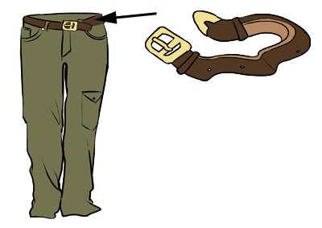

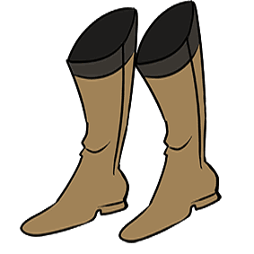

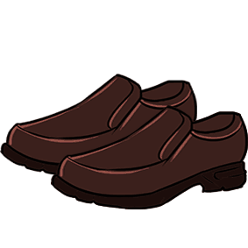

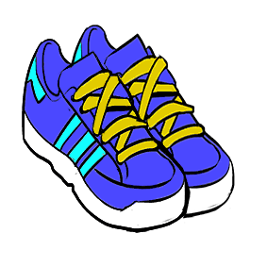

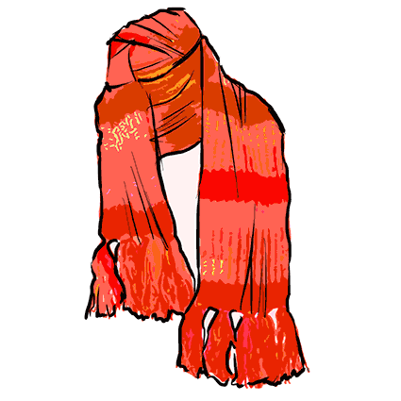

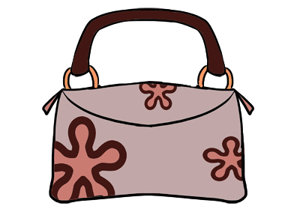

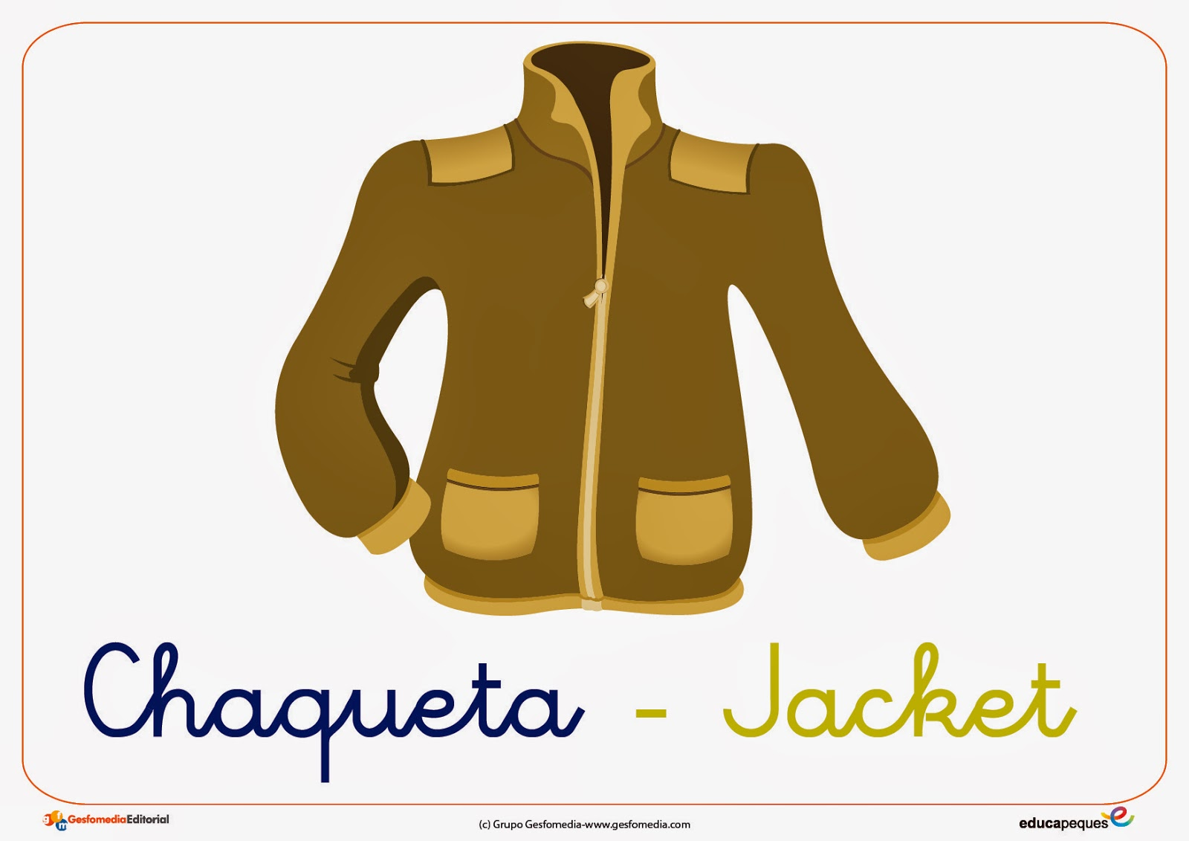

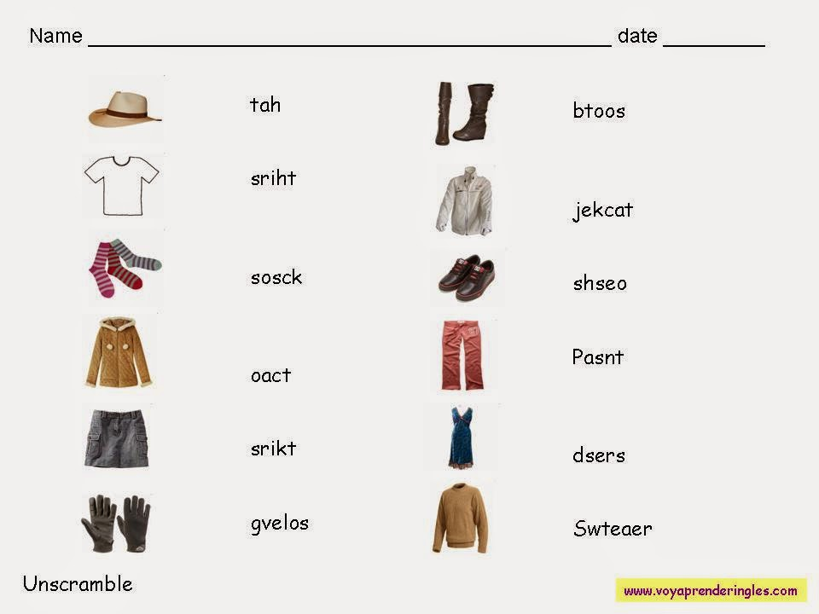

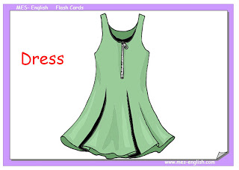

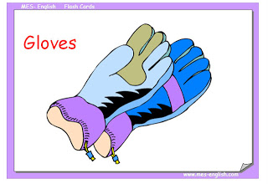

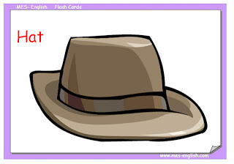

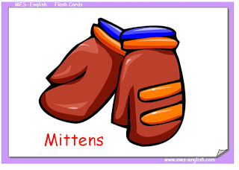

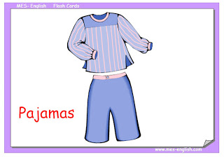

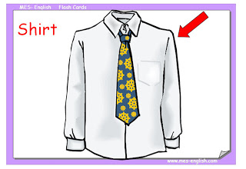

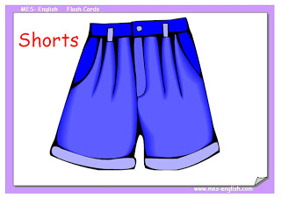

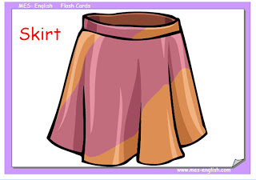
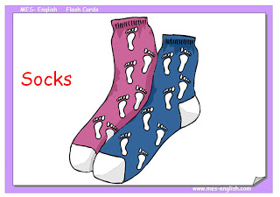

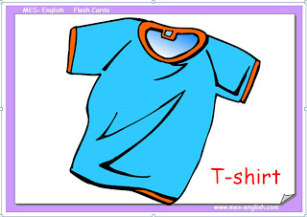

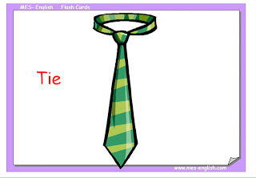

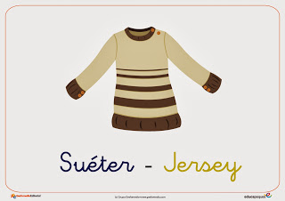
sombrero- Hat (jat)
Gorra – Cap (cap)
Bufanda – Scarf (scaarf)
Corbata – Tie (tai)
Pajarita – Bowtie (boutai)
Chaleco – Vest (vest)
Chaqueta – Jacket (yáket)
Sudadera – Sweatshirt (suet shert)
Americana – Blazer (bleiser)
Jersey – Jersey (yersi)
Camisa – Shirt (shert)
Camiseta – T-shirt (tishert)
Camiseta interior – Tank (tank)
Sujetador – Bra (bra)
Cinturón – Belt (belt)
Pantalón – Trousers, Pants (trausers , pants)
Pantalon corto – Shorts (shorts)
Vaqueros – Jeans (yiins)
Falda – Skirt (skert)
Vestido – Dress (dres)
Calzoncillos – underpants, knickers (anderpants, nikers)
Bragas – Panties (pantis)
Tanga – Thong (zong)
Calcetines – Socks (socs)
Medias – Tights (taits)
Zapatillas – Trainers (treiners)
Zapatos – Shoes (shuus)
Zapatillas de andar por casa – Slippers (slipers)
Tacones – Heels (gils)
Sandalias – Sandals (sandols)
Chanclas – Flip Flops (flipflops)
MY FAMILY TREE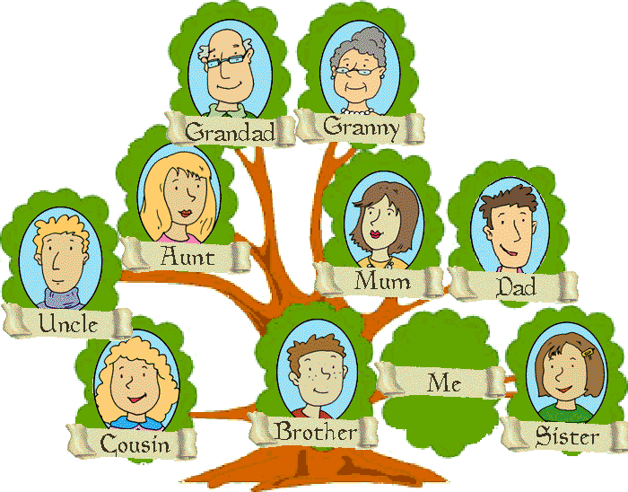
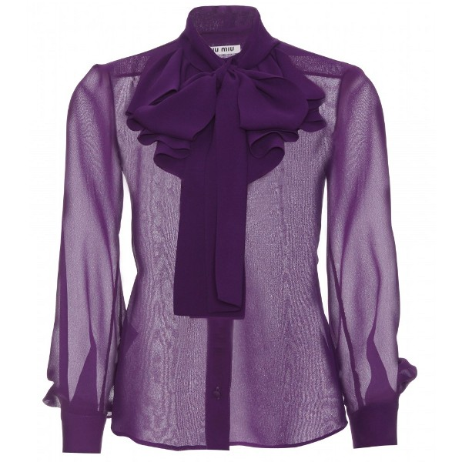

POSSESSIVE ADJECTIVES
WE USE THE POSSESSIVE ADJECTIVES MY, YOUR, HIS, HER, ITS, OUR AND THEIR BEFORE A NOUN TO SHOW POSSESSION, GO BEFORE NOUNS TO INDICATE OWNERSHIP
EXAMPLE: LUCIA IS MY SISTER
THIS IS HIS FRIEND
HER NAME IS ROSE
IS YOUR HOUSE BIG OR SMALL?

PERSONAL PRONOUNS SUBJECT FORM | POSSESSIVE ADJECTIVES
I | MY
YOU | YOUR
HE | HIS
SHE | HER
IT | ITS
WE | OUR
THEY | THEIR

DEMONSTRATIVES PRONOUNS
THEIR FUNCTION IS TO POINT AT SOMETHING.
THEY ARE VERY HELPFUL TO INDICATE SPECIFIC ITEMS IN RELATION TO OURSELVES.
THIS IS FOR A PERSON OR THING THAT IS NEAR US
EXAMPLE: LOOK AT THIS DOG
THAT IS FOR A PERSON O THING THAT IS FAR FROM US
EXAMPLE: I WANT THAT APPLE
THESE IS FOR PEOPLE OR THINGS THAT IS FAR FROM US
EXAMPLE: BUY THESE FLOWERS
THOSE IS FOR PEOPLE OR THINGS THAT IS FAR FROM US
EXAMPLE: THOSE MICE ARE UGLY

EXERCISES:

BIBLIOGRAPHY
  - ENGLISH TEACHER´S BOOK (2012) SABTUKKAA.
  - BYGRAVE, J. (2012) NEW TOTAL ENGLISH. STUDENTS’ BOOK – STARTER. ENGLAND: PEARSON.

- MITCHELL, H. & SCOTT, J. AMERICAN CHANNEL (2012) BEGINNERS STUDENT’S BOOK. EEUU: MM PUBLICATIONS.

- UNIVERSITY OF CAMBRIDGE (2013) ADVANCED LEARNER’S DICTIONARY. UNITED KINGDOM: CAMBRIDGE UNIVERSITY PRESS.

MG. ELENA CRISTINA GUERRERO PUELLES

